14.91: a) The fact that the water first moves upwards before leaving the siphon does not change the efflux speed, 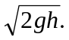 b) Water will not flow if the absolute (not gauge) pressure would be negative. The hose is open to the atmosphere at the bottom, so the pressure at the top of the siphon is 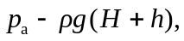 where the assumption that the cross-section area is constant has been used to equate the speed of the liquid at the top and bottom. Setting 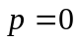 and solving for H gives 